COLLEGE OF COMPUTER STUDIES DEPARTMENT
THESIS PROJECT
TITLE PROPOSAL
(CS0025 – Software Engineering 1)

Group Name: Statisfied | Program:  Bachelor of Science in Computer Science  with specialization in Data Science
Member’s Name:  1. Dawn Andrei Pamesa (Project Manager)  2. Rogelio Porras (Member 1)  3. John Ashley Alba (Member 2)  4. Ralph Blanco (Member 3) | Term:  [✓] 1st [ ] 2nd [ ] 3rd | Academic Year:  2026 - 2027
Proposed Project Title 1:
Highland Vegetable Price and Supply Glut Forecasting at the Benguet Agri-Pinoy Trading Center Using XGBoost

1.0 Area of Investigation:
This section of the research proposal should give the reader enough information to be able to understand the background information and the importance of the research problem or investigation. It will often include a review of other people’s findings. If written well, this section will explain the motives for undertaking the research project.
This section should also contain the purpose of the system software, its features, and general description of each of its modules. If it is a game, the mechanics should be described as well.
[Joboy: Area of Investigation goes here, about 10 references reused from TA2.]

2.0 Background and Rationale of the Project/System:
This section should explain the key characteristics of the software project and explain why it will be developed. It contains the formal description of what is to be expected on the software project, what are the requirements, focus, and the desired outcome.
[Joboy: Background and Rationale goes here.]
Algorithm/Technique Justification
Identified Problem | [Ralph]
Computational Task | [Ralph]
Proposed Algorithm/Technique | [Ralph]
Reason for Selection | [Ralph]
Required Input/Data | [Ralph]
Expected Output | [Ralph]
Alternative Algorithm | [Ralph]
Evaluation Method | [Ralph]

3.0 Statement of Objectives:
This section states the research objectives (that may become or be part of your Statement of the Problem later) that will help you achieve your desired output. This should help identify clearly the variables to be measured. It is a clear and concise statement that provides direction to the investigation of the problem. In other words, it should be SMART: S-pecific, M-easurable, A-ttainable, R-ealistic, and T-ime Bound.
General Objective
To develop and evaluate, within an 18-week development schedule, a predictive analytics system that uses XGBoost to forecast short-term wholesale prices and flag supply-glut risk for selected highland vegetables traded at the Benguet Agri-Pinoy Trading Center (BAPTC).
Specific Objectives
- To build a cleaned and consolidated historical dataset of at least 10,000 records on the wholesale prices of at least five highland vegetables, such as cabbage, carrots, potatoes, Baguio beans, and Chinese cabbage, from DA Bantay Presyo price monitoring, Philippine Statistics Authority, and PAGASA weather records, with BAPTC trading volume added if it is released, by Week 4.
- To engineer and visualize forecasting features, including lagged prices, rolling averages, seasonal and calendar indicators, weather variables, and trading volume where available, by Week 6.
- To train XGBoost models that forecast weekly wholesale prices one to four weeks ahead and classify each commodity-week as at risk or not at risk of a supply glut, using an explicitly stated glut threshold, by Week 11.
- To evaluate the XGBoost models against seasonal naive, SARIMA, and random forest baselines using rolling-origin validation, measuring price accuracy by Mean Absolute Error (MAE), Root Mean Square Error (RMSE), and Mean Absolute Percentage Error (MAPE), and glut-risk detection by precision, recall, and F1-score, accepting XGBoost for a commodity only where it records a lower MAE than the seasonal naive baseline, by Week 13.
- To develop a web dashboard that presents price forecasts, glut-risk alerts, model performance, and downloadable commodity summaries, by Week 16.
- To assess the dashboard’s usability with at least five target users, drawn from BAPTC or DA-CAR staff where available and from agricultural market users otherwise, using the System Usability Scale (SUS) with a target average score of at least 68, by Week 18.

4.0 Scope and Limitations of the Study:
This section states the extent to which the research area will be explored and specifies all parameters within the study. In other words, you are to define the coverage of the study and its focus, and also the areas that it will not cover.
[Ralph: Scope and Limitations goes here. Public data first (DA Bantay Presyo, PSA, PAGASA); BAPTC data only as an extra. About 6 references.]

5.0 Target Beneficiaries:
This section identifies the group or groups that will benefit from your project. These are usually the people that will be indirectly or directly be affected by the project proposal. You need to describe their position in work, and how they will benefit from the project.
The primary beneficiaries are highland vegetable farmers in Benguet and nearby Cordillera areas. They may use early price and supply information when deciding whether to harvest, bring produce to the trading center, or seek alternative buyers. BAPTC personnel and traders are also direct beneficiaries because price and supply forecasts can support market monitoring, buyer coordination, and planning for possible oversupply.
Local market vendors, agricultural planners, and market analysts are secondary beneficiaries. They may use reliable commodity price and volume trends to anticipate supply conditions and make distribution or procurement decisions. According to the Department of Agriculture - Cordillera Administrative Region (2026), unsold carrots required market facilitation at BAPTC, showing that farmer income and produce quality can be affected when vegetables remain unsold.

6.0 SDG Category Number:
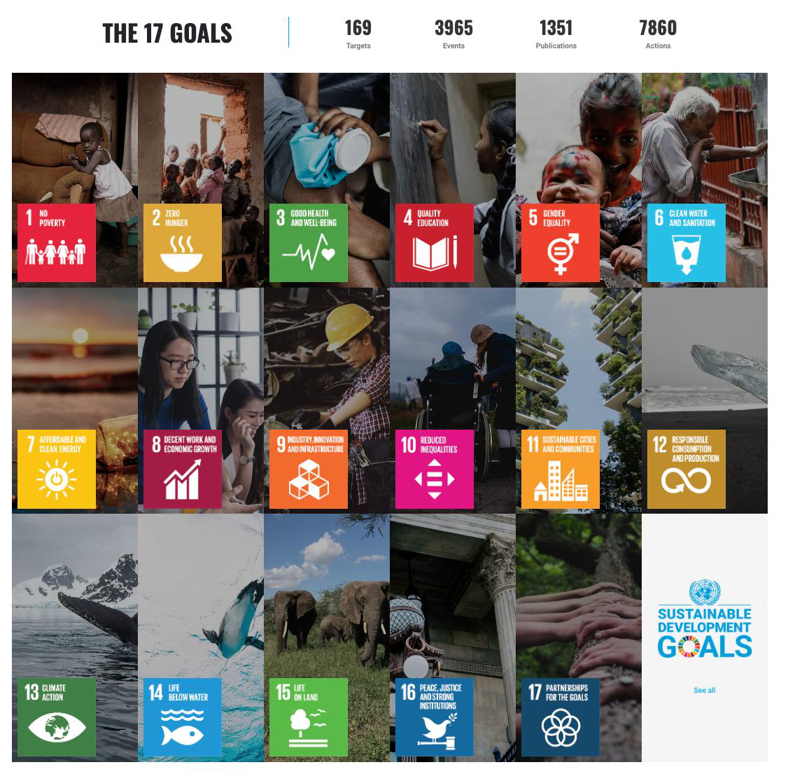
SDG Number: 2 and 8
SDG Title: Zero Hunger; Decent Work and Economic Growth
Justification:
Connection to SDG 2 Zero Hunger
The study supports SDG 2 by helping stakeholders identify possible vegetable oversupply before substantial quantities become unsold or spoiled. Based on Antolin, Flores, Neric, Estigoy, and Estimada (2024), carrot losses in Benguet increase when the commodity remains in the marketing chain for several days. Earlier supply-glut signals may help BAPTC personnel, farmers, and traders coordinate buyers, distribution, or alternative selling channels while vegetables are still marketable.
Aquino, Delos Reyes, and Catelo (2025) found that transportation difficulties, postharvest losses, unstable prices, and limited market access affect farmer profitability and consumer affordability in the Benguet vegetable value chain. Therefore, a forecasting framework may contribute to more informed supply management and support the availability of vegetables for consumers.
Connection to SDG 8 Decent Work and Economic Growth
The study supports SDG 8 because it may help protect agricultural livelihoods through better market decisions. Based on price and supply forecasts, farmers may be better able to avoid selling large volumes during periods of probable oversupply and unusually low prices. BAPTC personnel and traders may also use the information to coordinate market interventions and reduce preventable losses.
According to Aquino et al. (2025), price fluctuations and market-access constraints threaten the profitability of Benguet vegetable farmers. The DA-CAR case of unsold carrots further illustrates that vegetable marketing problems can result in lost income for farmers. The proposed system does not guarantee higher prices or income; however, it can provide timely evidence that supports more informed harvesting, trading, and distribution decisions.
Summary of Beneficiaries and SDG Contribution
Beneficiary | Possible Benefit | SDG Connection
Highland vegetable farmers | Earlier awareness of possible price drops and supply gluts before selling harvests. | SDG 8: Supports informed decisions that may reduce avoidable income losses.
BAPTC personnel and traders | Improved market monitoring, buyer coordination, and planning for possible unsold produce. | SDG 2 and SDG 8: Supports vegetable distribution and market efficiency.
Market vendors and consumers | More dependable information on vegetable supply conditions and possible price changes. | SDG 2: Supports the movement and availability of vegetables.
Agricultural planners and market analysts | Commodity price and volume trends for planning and market analysis. | SDG 2 and SDG 8: Supports data-informed agricultural market decisions.

7.0 References:
References should be written APA 6th edition format. These include online articles, books, published research (thesis and dissertation) and other published materials. As a rule, you cannot include an article or publication if the author is unknown, and you need to include as well the year. For your proposal, provide at least twenty (20) references.
Antolin, M. C. R., Flores, E. D., Neric, C. F., Estigoy, K. D. S., & Estimada, M. S. (2024). Postharvest loss of carrots: The case of Benguet, Philippines. International Journal of Multidisciplinary Research and Publications, 6(11), 140-144. Retrieved from https://ijmrap.com/wp-content/uploads/2024/05/IJMRAP-V6N11P42Y24.pdf
Aquino, L. L. M., Delos Reyes, J. A., & Catelo, M. A. O. (2025). Mapping and understanding food value chain networks of Benguet-sourced vegetables: The lens of the households (CIDS-DP-25-009). Quezon City, Philippines: UP Center for Integrative and Development Studies. Retrieved from https://serp-p.pids.gov.ph/publication/public/view?slug=mapping-and-understanding-food-value-chain-networks-of-benguet-sourced-vegetables-the-lens-of-the-h
Department of Agriculture - Cordillera Administrative Region. (2026, September 4). DA-CAR, BAPTC facilitate selling of over 1.2 tons unsold carrots. Retrieved from https://car.da.gov.ph/?p=9386
Philippine Statistics Authority. (2019, September 19). PSA approves the conduct of the 2019 survey on highland vegetable value chain analysis for use in policy formulation and future impact evaluation of agricultural trading centers. Retrieved from https://psa.gov.ph/content/psa-approves-conduct-2019-survey-highland-vegetable-value-chain-analysis-use-policy
[Joboy's and Ralph's references go here; the full list is sorted alphabetically at assembly. Target: at least 20.]

Approved by:

______________________
Panel Member 1 / Date

______________________
Panel Member 2 / Date

Noted by:

__________________________
Thesis 1 Course Adviser / Date

1. AI Interaction Log (if applicable)
If your group used any Generative AI tool while completing the assessment, document how the tool was used. The log should demonstrate that AI supported the group’s work rather than replacing the group’s research, analysis, and decision-making.
Group Member | AI Tool Used | Prompt / Purpose | AI Output Used For | How the Output Was Verified or Modified
Dawn Andrei Pamesa | Claude | Helped draft the Statement of Objectives and arrange the group's sections in the official template | Drafting assistance and document formatting | The objectives were checked against the project brief and revised by the group leader; every reference was checked against its original source
Rogelio Porras | [tool] | [waiting for Joboy's prompts] | [ ] | [ ]
John Ashley Alba | [tool] | [waiting for Ashley's prompts] | [ ] | [ ]
Ralph Blanco | [tool] | [waiting for Ralph's prompts] | [ ] | [ ]

2. AI Usage Declaration
We declare that any use of Generative AI in completing this Technical Assessment has been properly disclosed in the AI Interaction Log. We understand that AI is used only as an assistive tool and that our group remains responsible for verifying the accuracy, relevance, credibility, and originality of the submitted work.
We confirm that the final title proposal, objectives, scope, algorithm justification, and research outputs reflect our group’s understanding and decisions. All literature, studies, and other external sources used have been properly cited and verified.
Group Name: Statisfied
Date: September 27, 2026
Group Member | Signature
Dawn Andrei Pamesa
Rogelio Porras
John Ashley Alba
Ralph Blanco

3. Team Contribution Matrix
The total contribution percentage must equal 100%.
Group Member | Assigned Task/Responsibility | Specific Contribution/Output | Contribution (%)
Dawn Andrei Pamesa | Project Manager; Statement of Objectives; group information; quality check | Wrote the Statement of Objectives; checked all sections and references; prepared the AI documentation and contribution matrix; assembled, exported, and submitted the proposal | [%]
Rogelio Porras | Area of Investigation; Background and Rationale | Wrote the Area of Investigation and the Background and Rationale with their references | [%]
John Ashley Alba | Target Beneficiaries; SDG Category | Wrote the Target Beneficiaries and the SDG justification with their references | [%]
Ralph Blanco | Algorithm/Technique Justification; Scope and Limitations | Wrote the algorithm justification and the Scope and Limitations with their references | [%]
 |  | Total | 100%

